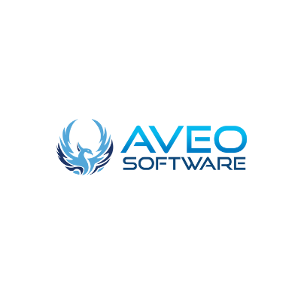

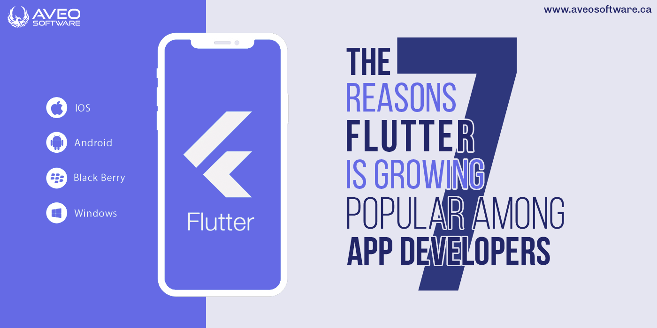

**7 reasons Flutter is growing popular among app developers**

Flutter's increasing popularity among app developers is somewhat surprising. The [cross-platform app development](https://aveosoftware.ca/flutter-developer/) framework seemed like any other when Google originally launched it in 2015. It was predicted that it would take years for things to pick up. However, with its formal release in 2018, it began to attract a growing number of developers.

While it is not yet [the most popular mobile SDK,](https://appfigures.com/top-sdks/development) it is gradually catching up. Many factors have contributed to its increasing popularity, and it is likely to continue in this direction in the foreseeable future. The popularity of the Flutter has risen dramatically in the last three years, as shown in the graph below. Why is this possible when React has reached a stalemate?

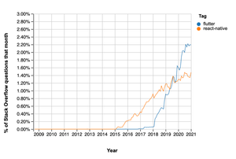Source: [Stack Overflow Trends](https://insights.stackoverflow.com/trends?tags=flutter%2Creact-native)

Thankfully, we'll go through seven reasons why Flutter is becoming increasingly popular among app developers today. So, let's get this party started.

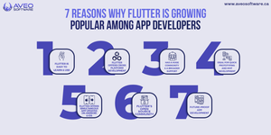

Seven reasons why Flutter is growing popular among app developers

**Flutter is easy to learn and use**

Flutter makes use of the Dart programming language, which is simple to learn and utilize. Flutter apps are easier to create and debug, and developers appreciate the ease of use and high functionality of a lightweight framework. As a result of the decreased entry barrier, Flutter has attracted a wide spectrum of developers of various skill levels to adopt it for their app development projects.

Flutter allows you to create code that is compiled into native code for both Android and iOS devices. Flutter applications have a huge performance advantage over other programs due to the compilation of native code.

Developers can see their code in action straight away during development, which saves time when building UI elements. It's feasible because to the hot reload capability, which is a key aspect for many developers looking to cut down on development time while increasing productivity.

**Flutter offers cross-platform development**

Nothing beats the convenience of being able to use a single workflow for many platform solutions. Flutter allows you to create a single piece of code that can be used to build native code for mobile, desktop, and online.

App developers can save time and money by developing apps for both Android and iOS platforms with a single codebase. Furthermore, cross-platform programming makes it easier to maintain the codes for both platforms' applications, making upgrades quicker and faster.

Flutter also features a large number of adaptable and versatile UI widgets that allow developers to create cross-platform apps faster by using pre-made widgets.

**Has a huge community and a broader support**

Flutter is a framework that is endorsed by Google and has a large community behind it. This assistance guarantees that work toward a more stable and functional cross-platform development platform is made. Despite the fact that Flutter is still relatively new, its open-source nature has attracted and retained thousands of developers.

Developers are comfortable with Flutter since the Dart language is known for being simple to learn and understand. Developers will constantly be enticed to explore Flutter because of the exceptional contribution of members of the Flutter community and their good documentation.

**Ideal for quick prototyping and MVP development**

Flutter is an excellent place to start if you're a startup looking to create a rapid MVP to test your ideas without incurring significant development costs. Flutter is a fantastic tool for new product ideas and testing because of its set of tools that allow you to generate rapid prototypes and convert them to native apps in minutes.

Flutter will continue to attract hundreds of developers and enterprises in need of MVP development services in this manner. Developers can also take code from the community and reuse it in their MVP projects, making it more appealing to developers with only little knowledge of the language.

**Flutter offers simultaneous app updates on Android and iOS**

Because writing Flutter applications is easier than writing native code for various platforms, many developers are looking for ways to cut down on their production time and difficulties.

As a result, Flutter enables developers to create apps more quickly and easily, which explains its growing popularity. Flutter also makes maintaining and developing new features across platforms a lot easier.

You alter one codebase during updates to rewrite all of the code for the supported platforms. If you had to handle it independently, such updates could entail more work for each of you.

As a result, app developers will select Flutter to simplify and speed up the update process.

**Flutter’s open source community**

Flutter is the most active open-source community, making it easier for app developers from all around the world to collaborate. Because more app developers are contributing to making Flutter better, it augments and complements other resources for assisting new members while also giving sophisticated solutions for pro members.

While having a community is usually a good concept, it's unusual to make those communities useful, accessible, and suitable for people of all skill levels.

As a result, it's understandable that Flutter would become so popular because it's easier to receive support and contribute to the platform, making it better and more popular.

**Future-proof app development**

[Google Fuchsia](https://fuchsia.dev/) is a new, interesting operating system from Google that is presently in development and fully supports Flutter-based apps. Fuchsia has the potential to replace Android in the future, so it's alive and well, and many app developers are looking at it.

While Flutter apps can run on Fuchsia, the OS is still in beta, therefore there are a lot of version mismatches that prevent the apps from being reliable on the platform. However, you can bet that Dart developers will start using it in production as soon as the stable version is released.

Flutter is becoming increasingly popular as a result of Fuchsia's fresh development, as more developers look forward to building long-lasting apps that will function on future platforms like the Fuchsia OS. As a result, Flutter's popularity grows as it prepares to become the official framework for Fuchsia apps, which many developers are interested in.

**Will Flutter’s popularity for Mobile App Development lasts longer in the future?**

The growing popularity of Flutter mobile app development could persist longer, thanks to the large community behind it, Fuchsia's backing, and the framework's ease of use.

Flutter's success is also due to the open-source community that is actively contributing to making Flutter better every day, as well as Flutter's ability to allow developers to design and update apps for both Android and iOS at the same time.